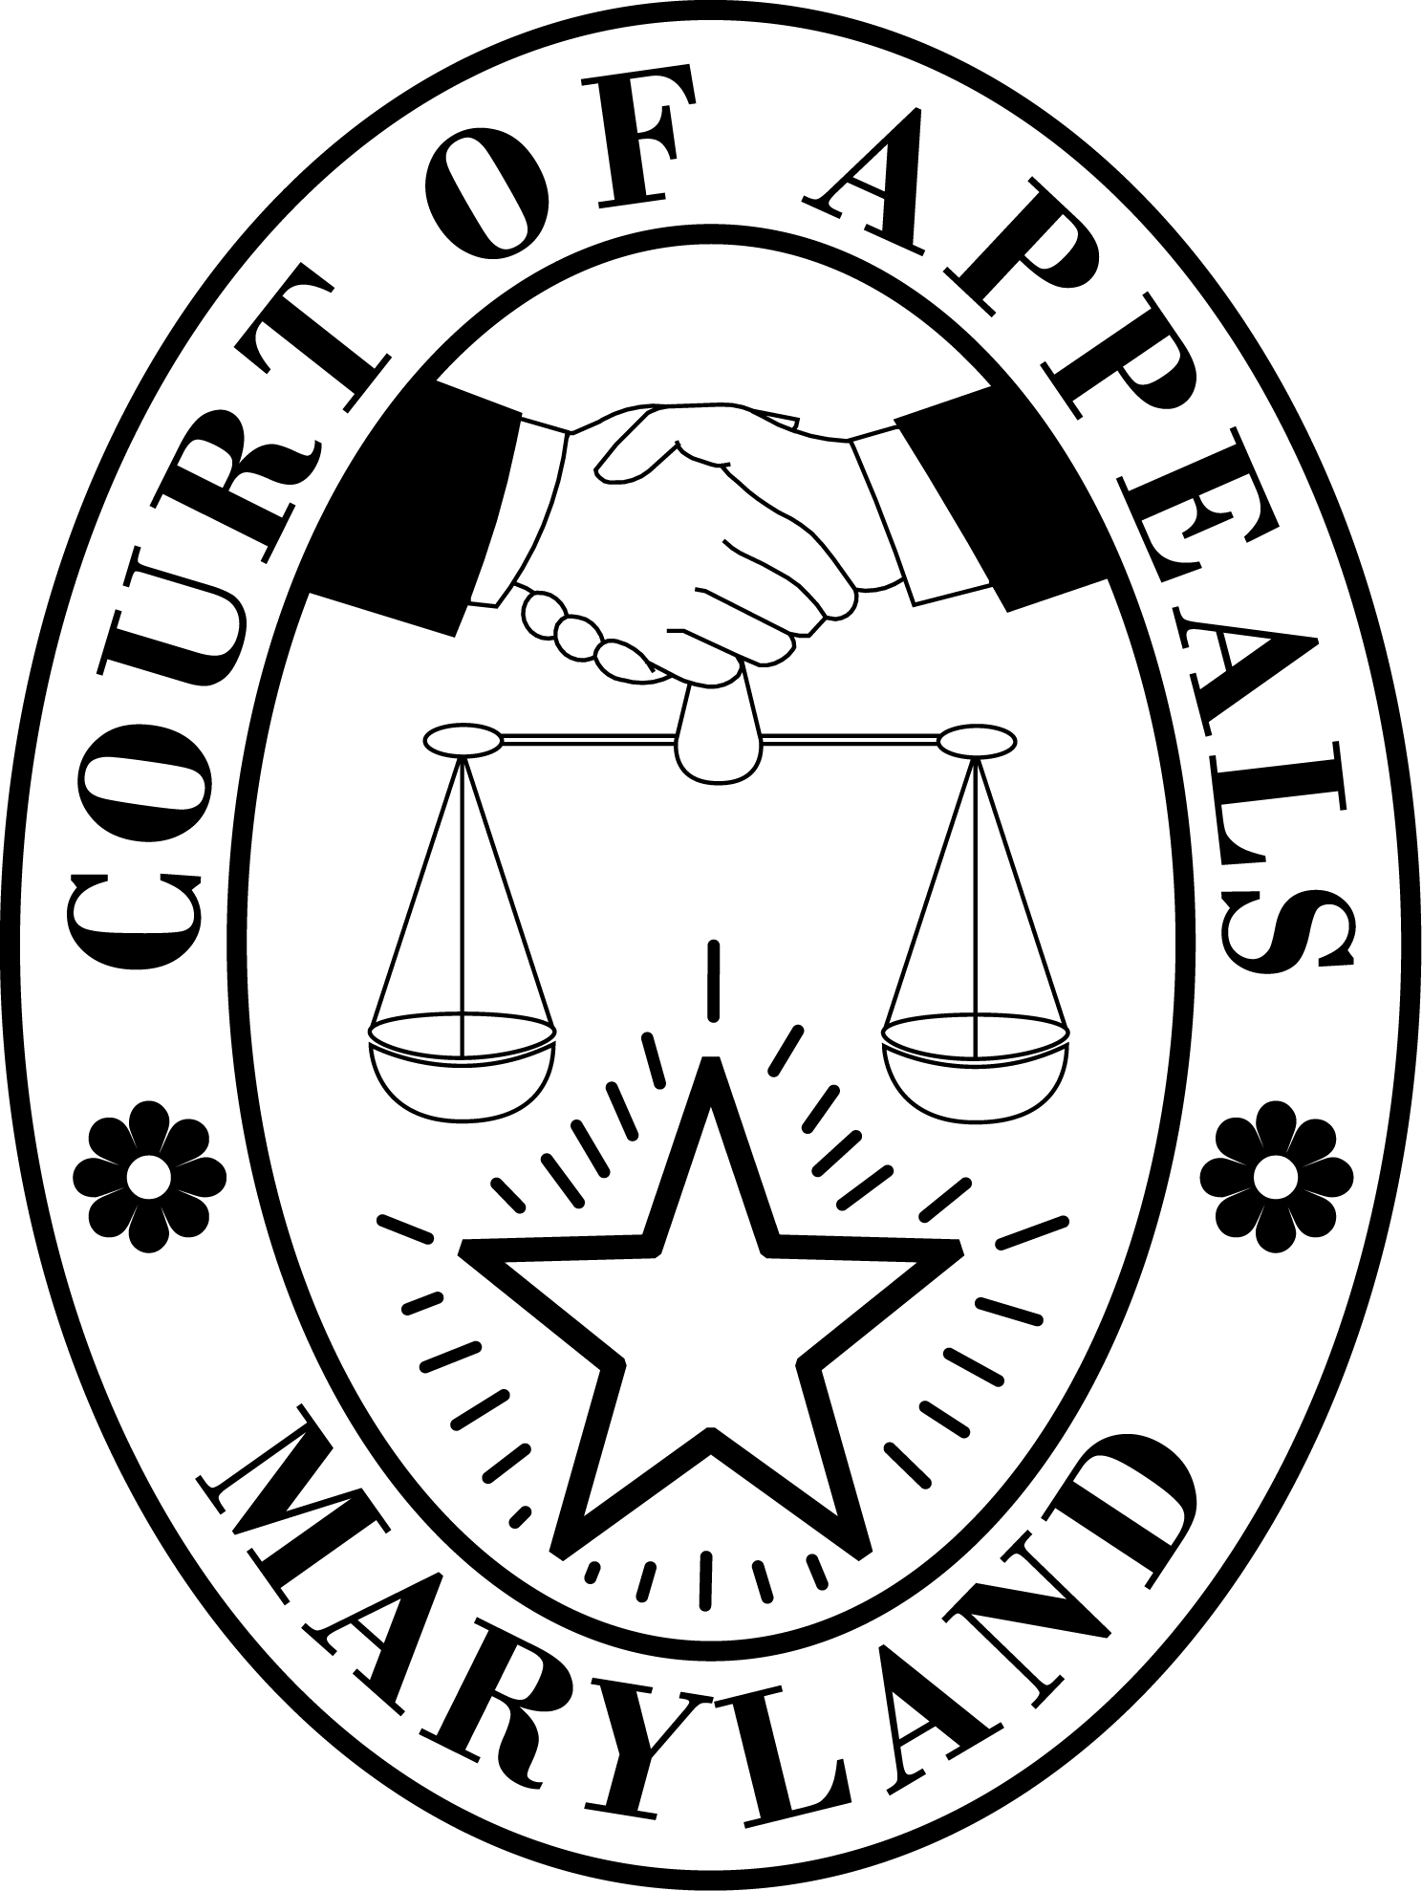
MEMBERS OF THE BOARD
JONATHAN A. AZRAEL, CHAIRMAN
JOHN F. MUDD
MAURENE E. McNEIL
DAVID E. RALPH
MATTHEW T. MILLS
GREGORY H. GETTY
MAURA L. LYNCH

SECRETARY & DIRECTOR
JEFFREY C. SHIPLEY

DIRECTOR, CHARACTER & FITNESS
BARBARA L. GAVIN

CLERK TO THE BOARD
NICOLE E. ADAMS

STATE BOARD OF LAW EXAMINERS
JUDICIARY A-POD
580 TAYLOR AVENUE
ANNAPOLIS, MD 21401
(410) 260-3640
MARYLAND-RELAY SERVICE (TT/VOICE) 1-800-735-2258
www.mdcourts.gov

TABLE OF FEES

UBE Applicants (Exam in Maryland or UBE Transfer)

Character Questionnaire by applicant planning to take the UBE in Maryland or transfer a Qualifying UBE Score to Maryland | $350
Notice of Intent to Take the UBE in Maryland (Filing deadline for July is the preceding May 20; filing deadline for a February exam is the preceding December 20) | $400
Notice of Intent to Transfer a Qualifying UBE Score to Maryland | $400
Out of State Attorney Applicants Seeking Admission Without Examination

Petition for Admission Without Examination | $700 to State Board of Law Examiners PLUS the appropriate fee as described on the NCBE Character & Fitness page for Maryland. (The NCBE portion may be paid online when completing the NCBE Character Questionnaire or by check payable to “National Conference of Bar Examiners” but sent to SBLE with hard copy filings)

