OVERVIEW

These instructions will assist you in using the State Board of Law Examiners’ (“SBLE”) online electronic bar application system (“eBar) to create a Maryland bar application.

UBE (Exam or Transfer) Applicants

Individuals who do not meet the eligibility requirements of Maryland Rule 19-215 to Petition for Admission Without Examination must either take the UBE in Maryland or transfer a qualifying UBE score to Maryland. Individuals applying in Maryland for the first time must complete and submit a Character Questionnaire (CQ) and an appropriate Notice of Intent (NOI). These two (2) documents are both generated within eBar.

Applicants who have previously taken the UBE in Maryland or the former Maryland General Bar exam one (1) or more times need only submit a NOI (but not CQ unless an updated CQ** is required). These “retake” applicants will follow the same process for filing a NOI as those taking the exam for the first time. eBar will produce the appropriate NOI for each applicant.

**Applicants whose CQ is stale (i.e., the CQ has been pending more than three (3) years since the most recently filed CQ) must file an updated CQ and pay a $100.00 update fee. The Updated CQ is discussed further on page 26 of this document.

Out-of-State Attorney Exam (Maryland Rule 19-215)

Applicants meeting the requirements of Maryland Rule 19-215 and wishing to file a Petition of Out-of-State Attorney for Admission Without Examination (OSA) may do so via the eBar system. Follow the instructions on pages 2 to 5 to create an eBar account, then proceed to the instructions for creating a Petition at page 25.

Hard Copy Filings Required

Please take note that applicants must not only create and submit their application documents electronically, but also mail or deliver hard copies of their CQ and NOI (or Petition) to SBLE with original signatures and supplemental documentation, as necessary, along with the appropriate fees.

For exam applicants, completed hard-copy CQs and/or NOIs must be RECEIVED in SBLE’s administrative office at by 4:30 pm on the filing deadline. Any hard-copy CQ and/or exam NOI submitted to SBLE’s office after the deadline or submitted by the deadline but incomplete (and where adequate remediation occurs after the deadline) will not be considered “filed” until accompanied by a request for good cause to file late. Applicants must meet the requirements of Board Rule 2 (“Filing Late for Good Cause”) in order for SBLE to consider the good cause request. Non-conforming good cause requests will be denied.

INSTRUCTIONS FOR FILING A BAR APPLICATION

Completing the bar application begins with creating an eBar account. To access eBar, click on the link for the eBar Account Login (All User Roles) on the top of the left-hand menu of SBLE’s website – www.mdcourts.gov/ble/

Creating an Account

On the Welcome screen, click on the “Create Account” link found near the login boxes.

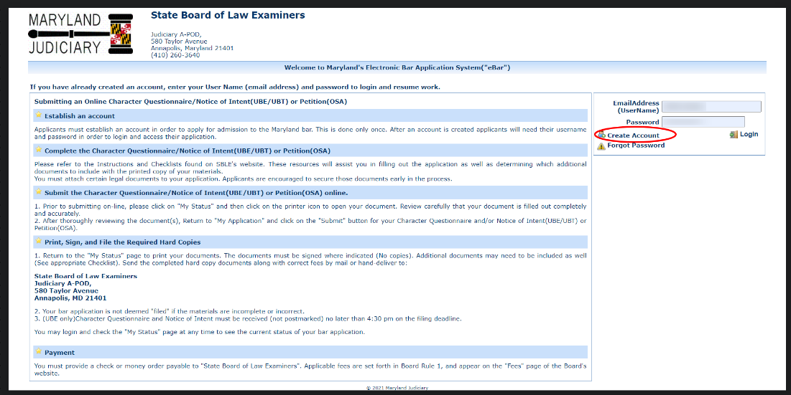

Fig. 1 – Welcome Screen for the eBar system

[Next page]

You will be taken to the account creation form:

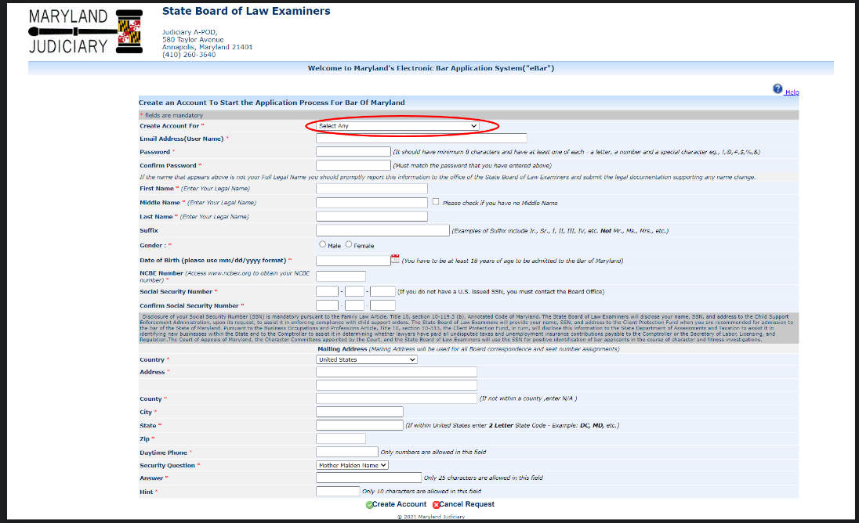
Fig 2 – Account creation form

Select the appropriate User Role: UBE Exam in Maryland; UBE Transfer; Out of State Attorney Admission Without Examination (OSA).

Complete all required information (marked with a red asterisk “*”). In eBar, your e-mail address becomes your Username. It is critical that the e-mail address you provide remain current and active at all times during the course of the examination process- from the time you create your account through the swearing-in ceremony. SBLE recommends using a personal email address rather than a work or school email address, which may change or become unavailable unexpectedly. Your password must contain a minimum of eight characters and must contain at least one (1) letter, one (1) number, and one (1) special character (! @ # $ % & or *). Passwords are case sensitive.

NOTE: In order to apply for an eBar account, you must disclose your U.S. Social Security number, pursuant to Md. Code Ann., Family Law, §10-119.3(b). If you do not have a valid Social Security number, you must contact SBLE’s office by telephone (410-260-3640) prior to completing your account for instructions on how to proceed.

In order to create an account in eBar you must obtain and disclose an NCBE number issued by the National Conference of Bar Examiners. You may already have an NCBE number incidental to registering for the Multistate Professional Responsibility Exam (MPRE) or another other NCBE exam. If you do not yet have an NCBE number, the process for obtaining one is simple. You should navigate to www.ncbex.org. At the top of the page on the right-hand side is an orange button reading “NCBE Account.” Just click and register. There is no charge to register for an NCBE number.
As you fill out the required fields to create your user account, review your entries carefully before you save your data.
- Check carefully to avoid errors in entering data for Social Security number, date of birth, place of birth, suffix, prefix, etc.
- Your entries in eBar will carry through to your printed bar application, your exam results letter, and eventually, your bar admission certificate. As such, please ensure that entries are properly capitalized (no ALL CAPS, no “all-lowercase”)
- Be on the lookout for “auto-complete” errors, which may occur unnoticed.
- Before filing your bar application, errors may be corrected by calling or emailing SBLE’s office.
- After filing your bar application, mistakes may only be corrected by sending a signed letter to SBLE noting the error and correction to be made.

When all fields have been completed and double-checked, click “Create Account.”

Activation Email - After submitting the required information to create an eBar account, you will receive a confirmation e-mail that you will use to activate your account. Please be aware of the privacy and spam settings on your e-mail account, and ensure that “ebar@mdcourts.gov” is whitelisted in your spam settings. The email text is as follows:

Dear [APPLICANT NAME],

Welcome to Maryland e-bar application process. You have successfully registered to our website. However, to access your account and continue with the application submission process you will have to activate your account.

To activate your account, click on the link "Activate your account" below. Activate your account

If you cannot click on the link above, please copy and paste the link below to your browser. https://jportal.mdcourts.gov/ebarapp/account.activate?q=48561&u=c800f932a9044149edc36af64dc986
4f&d=c28765dbec337b186ca583e07292b3b

Sincerely,

Jeffrey C. Shipley
Secretary, State Board of Law Examiners

You MUST click on the “Activate your account” link before you can log in to eBar to create your application. If you do not receive an activation e-mail within a few hours of creating your user account, contact SBLE at (410) 260-3640 during normal business hours (M–F 8:30am to 4:30pm) to have your account manually activated.

CAUTION: In the past, e-mail account providers hosted with “.net” domains (e.g., comcast.net, verizon.net, att.net, etc.) and AOL have had trouble accessing with eBar. SBLE strongly recommends that applicants with “.net” and AOL email addresses create a “.com” email address for use with eBar. SBLE does not endorse any particular “.com” but has noted that Gmail, Yahoo, and Hotmail function properly with eBar.

CAUTION: Applicants using “.edu” email addresses issued by their law schools and/or colleges must ensure that their institution does not “turn off” access to that email address after graduation. If unsure, another email address should be utilized.

CAUTION: Passwords and Security Question Answers are case-sensitive. The system will lock the account after five (5) failed login attempts. Please utilize eBar’s “Forgot Password” system to recover your forgotten password prior to locking yourself out. Applicants who become locked out must contact the Board’s Office by telephone (410-260-3640) during normal business hours (8:30a to 4:30p M-F) to unlock their account. Email requests to unlock eBar user accounts cannot be honored due to Md. Rule 19-105 confidentiality safeguards.

[OSA applicants proceed to page 25; UBE Exam and UBE Transfer applicants continue next page.]

Filling Out the CQ and/or Notice of Intent for UBE Exam and UBE Transfer applications

After activating your account, you will be able to log in to eBar and begin your UBE Character Questionnaire and/or Notice of Intent.

Upon logging into eBar, you will land on the “My Status” screen, which shows a number of useful pieces of information.

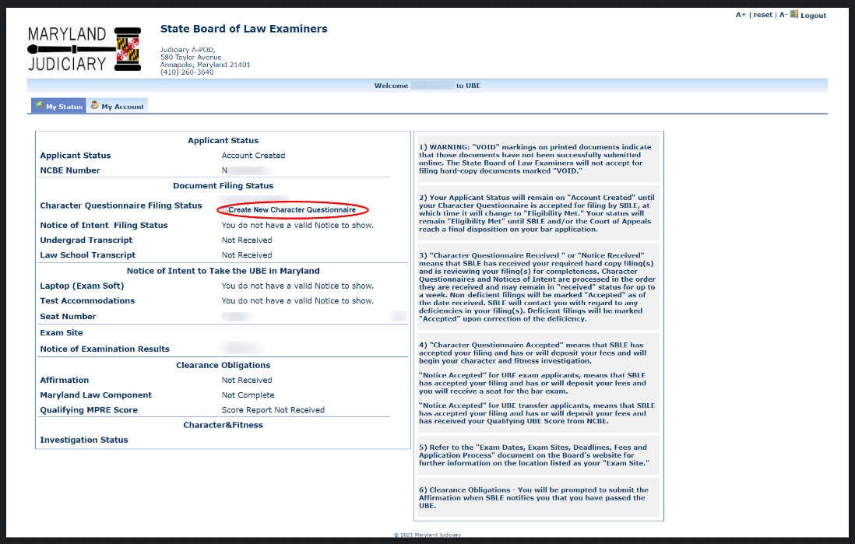

Figure 3 – “My Status” screen (UBE Exam in Maryland shown)

Click on the “Create New Character Questionnaire” button to begin the online application process and automatically moves you into the first page of the Character Questionnaire – “Personal Identification”.

Note - On the top right of your screen, you will see screen viewer adjustments (A+, reset, and A-). The screen viewer adjustments appear on each page of eBar.

[Next page]

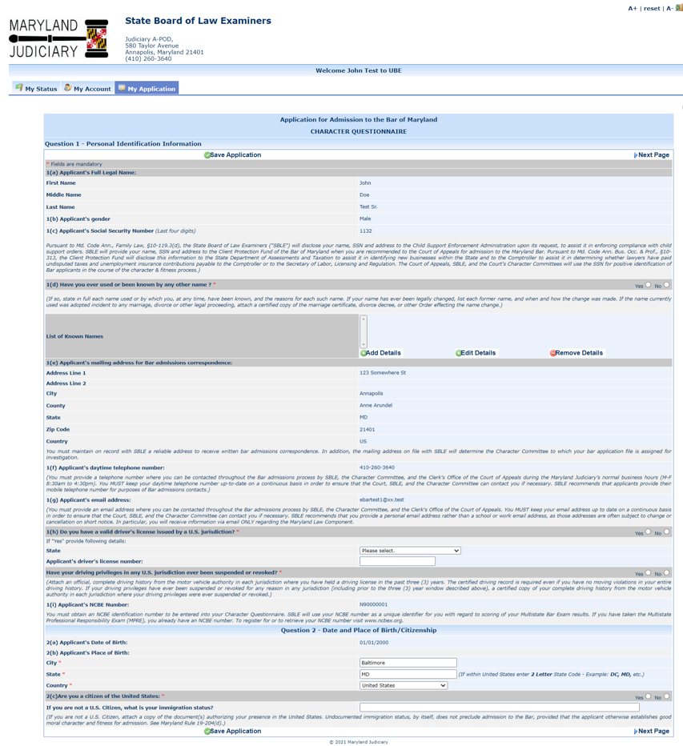
Figure 4 – “My Application” Page 1

The majority of fields on this page are pre-filled with information from the account creation screen. Complete each item marked by a red asterisk “*.” Then, click “Save Application” at the bottom of the screen, which will take you to the next page of the Character Questionnaire.
[Next page]
Adding/Editing Details

Some items on the Character Questionnaire require the applicant to “Add Details” (such as to enter information for aliases, residences, employment, marriage details, etc.).

For example, in Figure 5, below, Applicant John Test indicates that he was previously known by another name. Applicant John Test must now “Add Details” regarding his former name.

Click on the “Add Details” button.
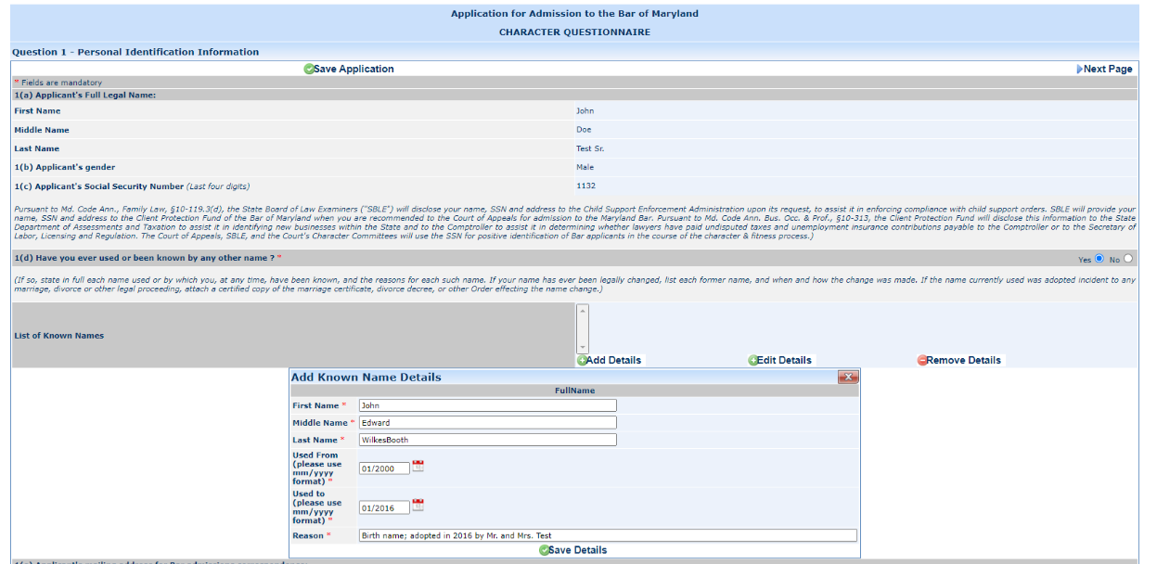Figure 5 – “My Application” Page 2
Clicking the “Add Details” button will open a dialogue box, where you will enter your detail information. Then, click “Save Details.” You can also edit previously added details by highlighting the entry you wish to edit and clicking on the “Edit Details” button. Revise the detail information, then click “Save Details.” John Test has clicked on “Add Detail” and entered his former name, John Edward WilkesBooth and other information about use of a former name.

After entering the required information, click “Save Details” at the bottom of the dialogue box. This will return you the current page of the Character Questionnaire. On any give page, if you have additional details to add (e.g., multiple employers, multiple residences), click “Add Details,” enter the information, click “Save Details,” and repeat as many times as needed.

CAUTION: Do not click on “Save Application” when you are in the “Add Details” box. Your details information will not be saved. You must first save the information within the “Add Details” box by clicking on the “Save Details” button.

[Next page]

Figure 6, below, shows that John Test’s Character Questionnaire now lists his former name – John Edward WilkesBooth.

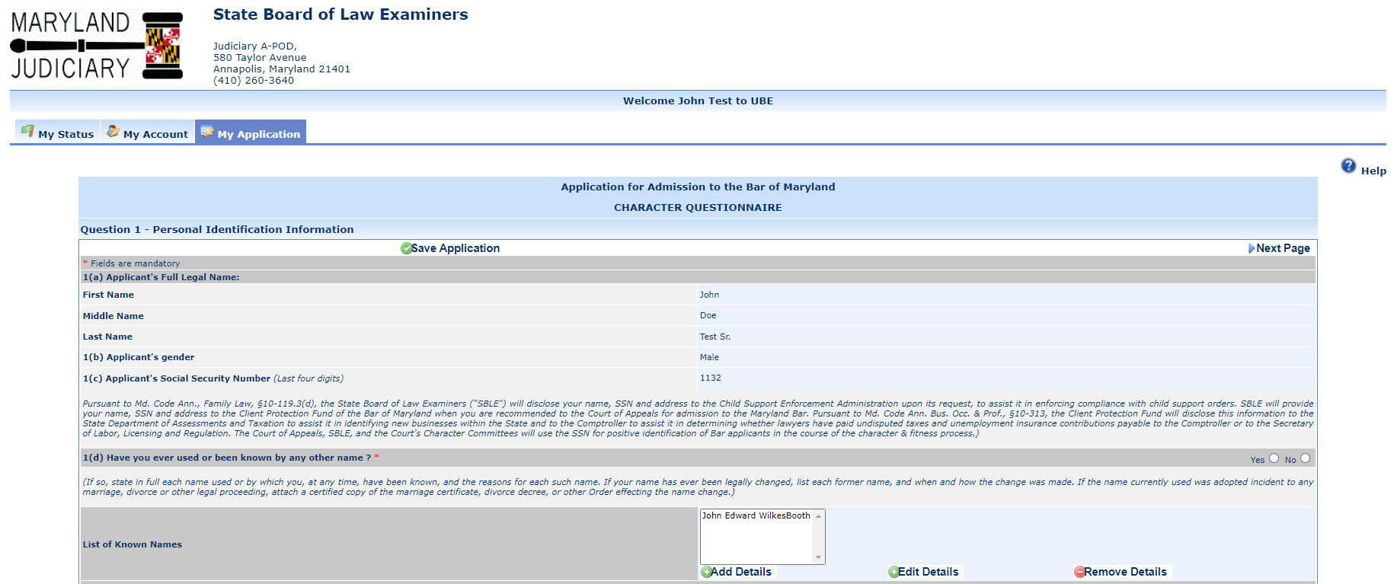

Figure 6 – “My Application” page 2 (partial, showing former name)

Moving from page to page in eBar

You must click on “Save Application” (at the bottom center of each page) when you are ready to move on to the next page. (See Figure 8, below.) If you do not click “Save Application” at the bottom of each page, you will lose the data you entered for that page. However, first review the data you entered to ensure it is completely filled in and correct before you save it. You must complete an entire page of the application to “Save Application.” Trying to save an incomplete page will generate an error message.

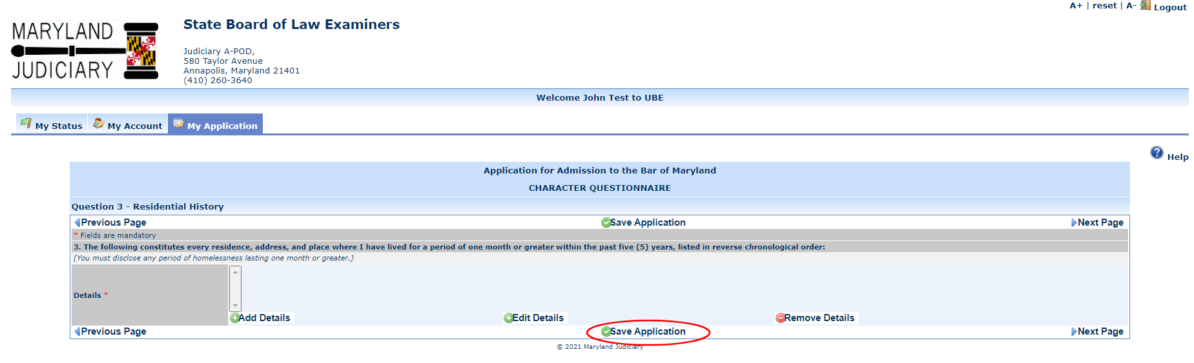
Figure 7 – “Save Application” button

[Next page]

Viewing the “My Application”Checklist

As you complete the Character Questionnaire, eBar creates a checklist of the CQ sections you have completed. Clicking the “My Application” link on the top menu displays this checklist.

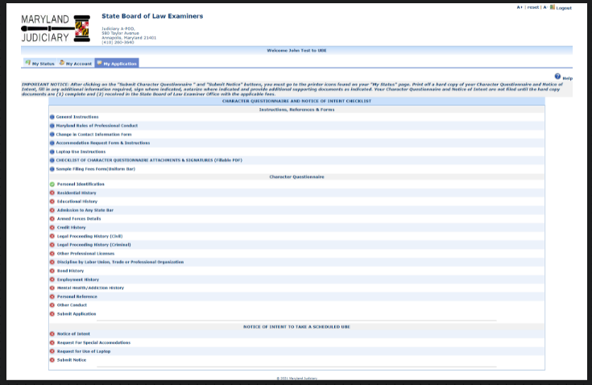

Figure 8 – My Application checklist

TIPS: If you exit eBar before submitting your electronic CQ, you may resume entering data by logging back in and accessing your CQ and/or Notice of Intent in the “My Application” page. The pages you have completed will be marked with a green “”. (See Figure 9, above.) You may navigate directly to a page by clicking the page name in the list.

[Next page]

Submitting the Electronic CQ

A green “” next to each item in the CQ section of the “My Application” checklist indicates that you are ready to submit your CQ.

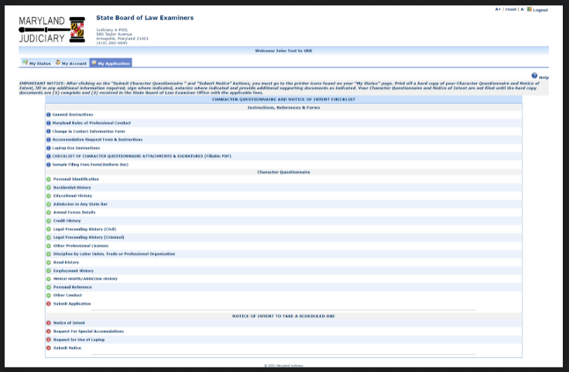

Figure 9 – My Application Checklist – Ready to Submit

You may generate a PDF of your CQ at any time by clicking the printer icon visible in the “CQ Filing Status” section of your “My Status” page.

When you are certain that you have entered and double-checked all required information, click on the “Submit
Application” link at the bottom of the “My Application” Checklist. (See Figure 10, above.)

[Next page]

If your submission is successful, you will receive a message toward the top of your screen (see Figure 11, below).
Also, the “Submit Application” link will display a green “”

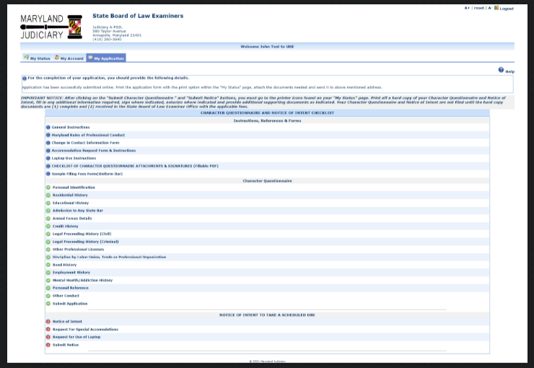

Figure 10 – My Application checklist showing successful submission message and

You should then go to your “My Status” page.

[Next page]

The “My Status” page will indicate that your Character Questionnaire has been submitted online and display printer icons.

Your CQ is ready to be printed, signed and filed with SBLE.

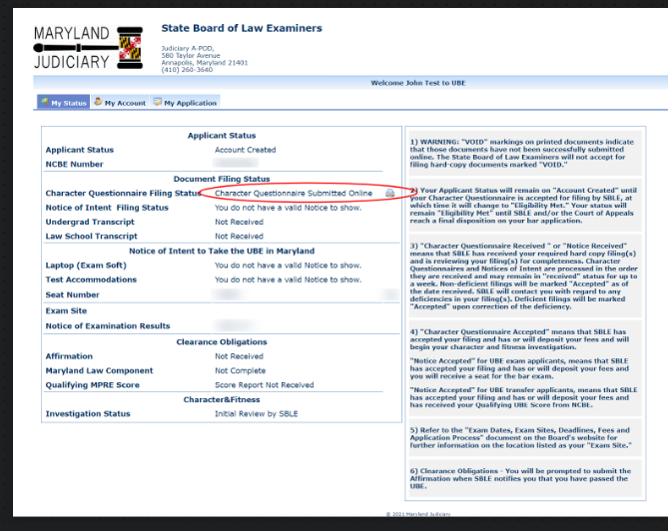

Figure 11 – My Status page showing “Character Questionnaire Submitted Online” and printer icons

[Next page]

Completing the Notice of Intent to Take a Scheduled UBE in Maryland

(UBE Transfer applicants go to page 19)

Once UBE Exam applicants have completed and submitted the CQ, a red “x” will remain by the “Notice of Intent,” “Laptop Request,” and “Accommodations Request” links.

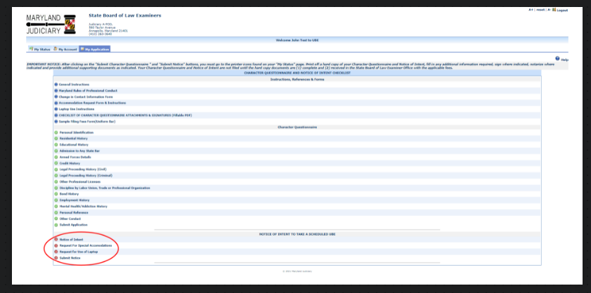
Figure 12 – My Application showing incomplete NOI

Exam applicants must click on “Notice of Intent to Take a Scheduled UBE” and then fill out the fields for the Notice of Intent. The process is the same as for filling out the CQ, except however, you must complete the Notice of Intent, Laptop Request and Accommodations Request screens in one session. Otherwise, your Notice of Intent will not be saved.

[Next page]

eBar will pre-fill most of the fields with identifying information from your account. Select the exam session you plan to take from the dropdown box. Complete the required fields (“*”) at the bottom of the page and click “Save Application.”

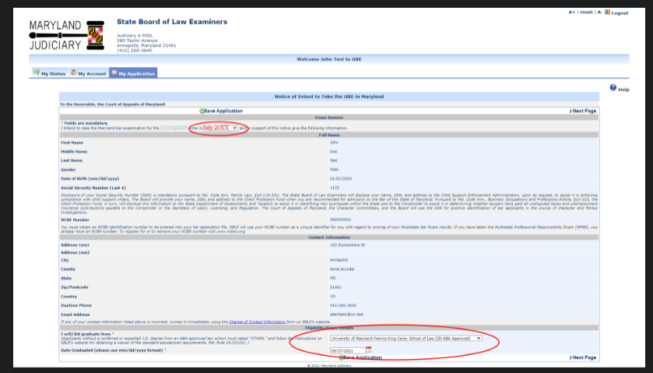
Figure 13 – Notice of Intent to Take the UBE in Maryland

Then click, “Next Page” (to the right of “Save Application.) You will be taken to the Laptop Request screen.

[Next page]

Laptop Use Request

If you wish to use a laptop on the UBE, click the radio button for “Use a laptop computer for the written test.” You must also check the box on the lower left-hand side of the screen that you have read, understand and agree to the terms relative to your request. Then, click “Save Application,” and “Next Page” to be taken to the “Accommodations Request” page.

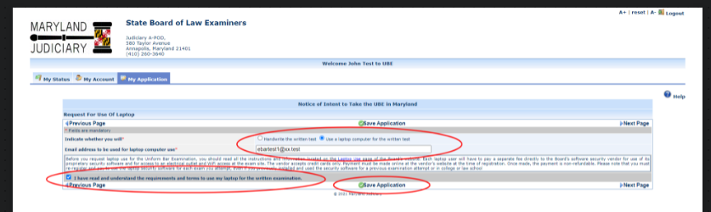

Figure 14 – Laptop Request page

CAUTION: The Laptop Request in eBar is only the first step in the laptop use process. Applicants who wish to use laptop computers for the Day 1 (Essay Day) portion of the Maryland bar exam must (1) check the laptop designation in eBar first AND register their laptop with SBLE’s software vendor, in accordance with the policy on laptop use found in the “Exam Day Information” linked on the Board’s website.

[Next page]

Accommodations Requests

Applicants planning to request an ADA testing accommodation must click the radio button for “Yes” in response to the question, “Are you applying for test accommodations for the Bar Exam. You must also check the box indicating review of the terms and conditions. Then, click “Save Application, which will return you to the “My Application Checklist.”

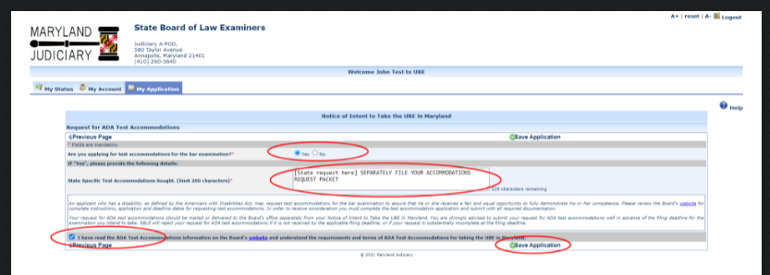

Figure 15 – Request Test Accommodations screen

CAUTION: Applicants who plan to request ADA testing accommodations for the Maryland Bar exam must (1) complete the “Request for Special Accommodations” in eBar AND (2) print the Instructions and Applicant’s Accommodations Request Form, fulfill all the requirements therein, and mail/hand-deliver a complete and fully documented Request Form to the Board’s Office by the filing deadline. The Applicant’s Accommodations Request Form may be found at: Accommodations Request Form on the Board’s website.

[Next page]

On the “My Application” screen, click “Submit Notice.” Each line of the Notice of Intent section will show a green
“.”

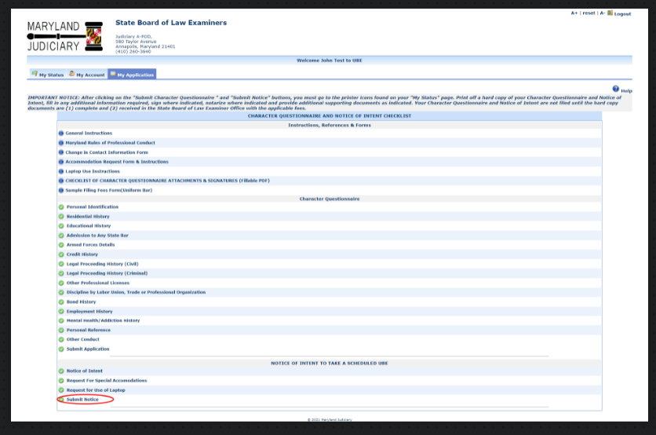

Figure 15 – My Application page after submission of Notice of Intent

You have now completed the process of creating and submitting your CQ and NOI online, BUT YOU ARE NOT FINISHED. You must still print and submit hard copies of your CQ and NOI with all required signatures and supporting documentation.

[Exam Applicants, go to page 23]

Completing the Notice of Intent to Tranfer a Qualifying UBE Score to Maryland

Once UBE Transfer applicants have completed and submitted the CQ, a red “x” will remain by the “Notice of Intent to Transfer a Qualifying UBE Score” link.

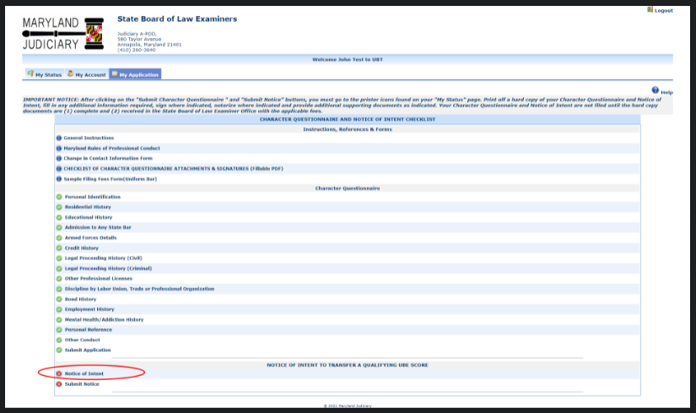

Figure 16 – My Application page for UBE Transfer role

BEFORE attempting to create a NOI, UBE Transfer applicants must ensure that SBLE has confirmed receipt of their qualifying UBE score from NCBE. Order your UBE score report via your NCBE Account at www.NCBEX.org. SBLE will record your score in your eBar account and notify you by email when it has done so.

When your score has been recorded in your account, click on “Notice of Intent” and then fill out the empty fields at the bottom of the NOI.

[Next page]

- Enter the law school from which you graduated and the date of your graduation.
- Select the state in which you earned your qualifying UBE score and the date of exam on which you earned your qualifying score
- Enter your qualifying UBE score as reported to SBLE by the NCBE.

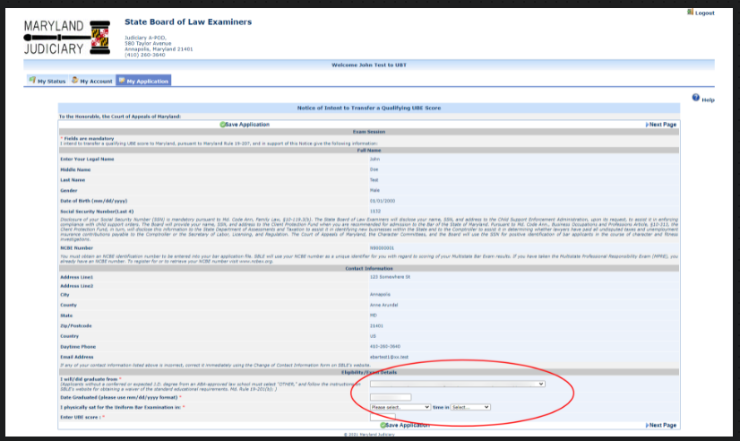
Figure 17 – Notice of Intent to Transfer a Qualifying UBE Score to Maryland

After filling out the required fields, click “Save Application” to be returned to the My Application page.

[Next page]

Click on the “Submit Notice” link at the bottom of the page to electronically submit your Notice of Intent.

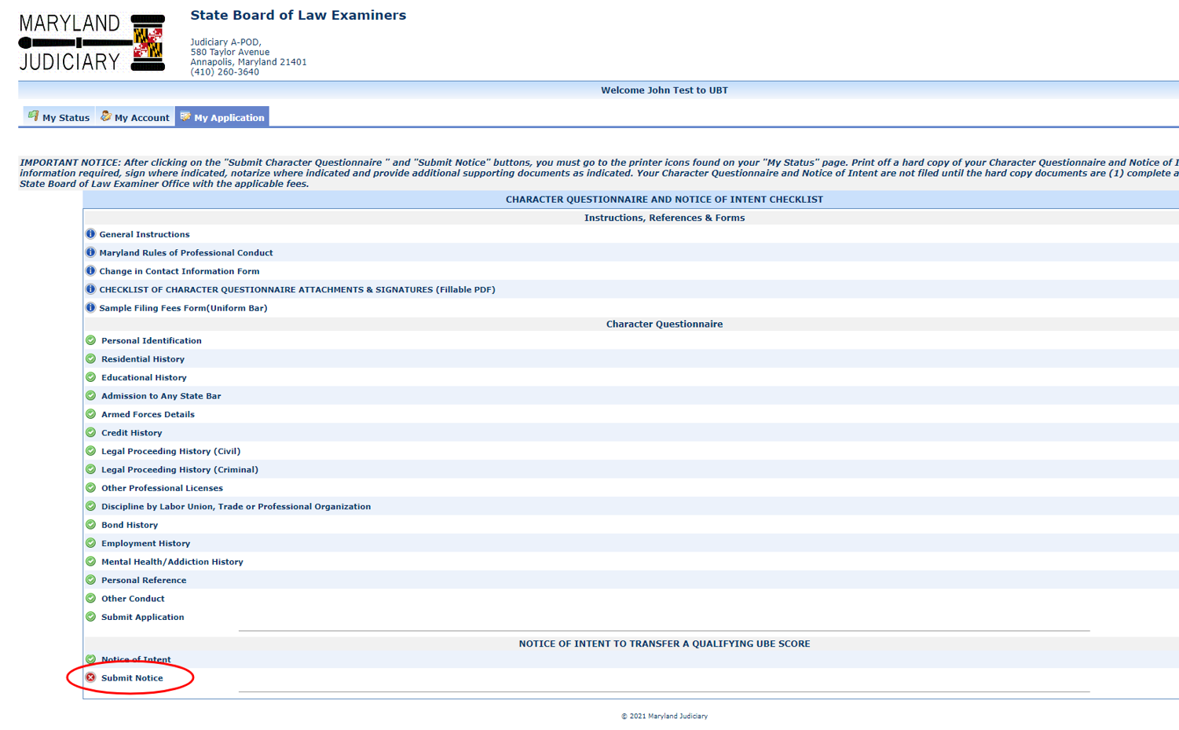
Figure 18 – My Status page for UBE Transfer

[Next page]

A correctly submitted NOI will show a green checkmark on the last line and there will be success message at the top of the screen:

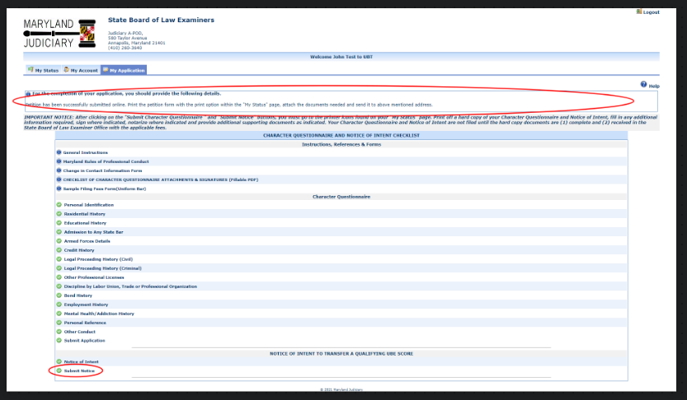

Figure 19 – Correctly submitted Notice of Intent

YOU ARE NOT FINISHED. You must go to the My Status tab to print your CQ and NOI for filing.

[Next page}

PRINTING and FILING YOUR HARD COPY CHARACTER QUESTIONNAIRE AND/OR NOTICE OF INTENT

Once you have submitted your CQ and NOI electronically, go to your “My Status” page. You should see (1) a printer icon for the CQ and (1) a printer icon for the Notice of Intent.

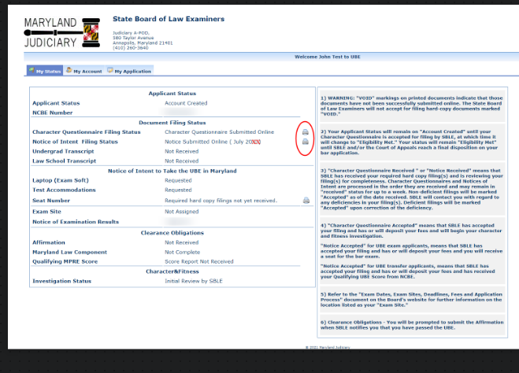

Figure 20 – “My Status” showing printer icons.

Click on the icon(s) to print hard copies of your CQ and NOI.

CAUTION: If your printed document(s) contain(s) a “VOID” watermark, you did not electronically submit the documents. Go back to “My Application” and scroll down to the bottom of the page until you see “Submit Application” and/or “Submit Notice”. Click on Submit and look for your confirmation message. Then return to My Status and re-print the document(s). You should now have no “Void” watermarks.

You must sign each document where indicated. You must also provide supplemental documentation as necessary in order for your bar application to be complete. Locate the CQ Attachments Checklist on SBLE’s website for details of the required attachments

Only completed CQs and NOIs submitted online and in hard-copy with the required signatures and filing fee(s) will be treated as “filed” by SBLE. When SBLE processes your hard copy CQ and NOI along with original signatures and supplemental documents, your “My Status” page will display changes to your status. You may also receive e-mails from the eBar system when your status changes.

CHARACTER QUESTIONNAIRES PENDING MORE THAN THREE YEARS

UBE Exam and Transfer applicants (including former General Bar Exam applicants) whose Character Questionnaires have been pending more than three (3) years since the most recently filed CQ must complete and electronically submit an Updated CQ before eBar will permit the creation and submission of a Notice of Intent to Take a Scheduled UBE in Maryland or a Notice of Intent to Transfer a Qualifying UBE Score. Click Create New Character Questionnaire to start the update process. If an update is required, you may not file a new Notice of Intent in our office to take a scheduled bar examination until the completed new updated Character Questionnaire is filed in our office along with the prescribed update fee.

eBar will permit you to copy the information from your prior electronic Character Questionnaire in order to assist you in completing your new Updated Character Questionnaire. You will only have this option once. If you leave the page or skip the option to copy your old data to the new CQ, you will have to reenter all of your former information from scratch. The “copy” function is only available if you have previously submitted an original application or updated application after October 4, 2010 in the eBar system.

Except as noted below, the Updated Character Questionnaire must be printed, signed and filed in the same manner as the original Character Questionnaire, along with the prescribed fees and attachments.

[End of document for UBE Exam and UBE Transfer applicants]

Creating a Petition for Admission Without Examination

To create a Petition, click “Create New Petition” from the My Status page.

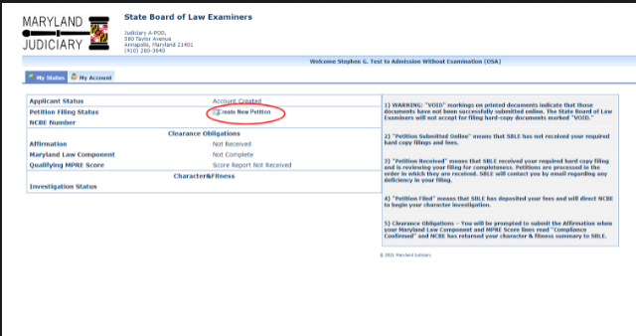

Figure 21 – My Status page for OSA role

Most of the fields will be populated by your account information. Answer the questions at the bottom of the page.

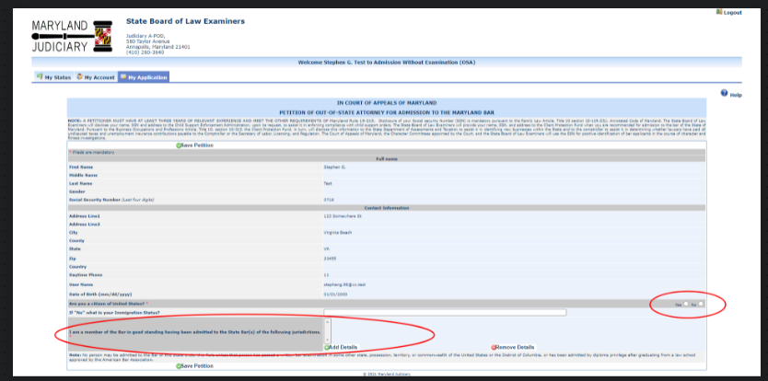
Figure 22 – Petition showing questions to be answered
[Next page]
To answer the question regarding prior bar admissions, click the “Add Details” button. Enter the details of your prior bar admission in the dialogue box. Click “Save Details.” If you have more than one prior bar admission, you must “Add Details” and “Save Details” separately for each admission.

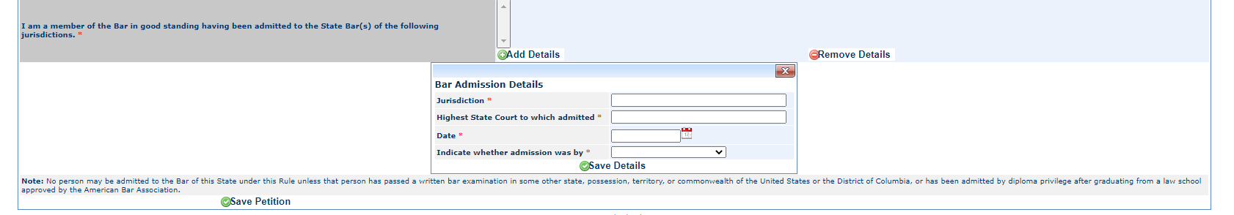
Figure 23 Petition (partial) showing Bar Admissions Details Box

After adding and saving details for all bar admissions, click “Save Petition.”

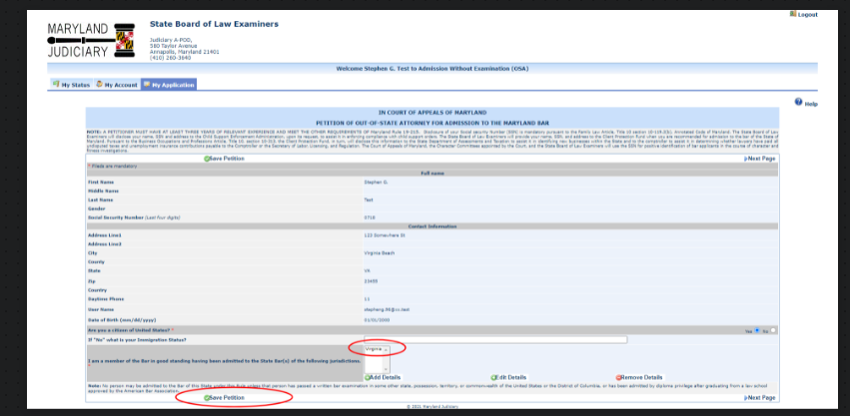

Figure 24 - Completed Petition

[Next page]

“Save Petition” will return you to the My Application screen where you will see “Submit Petition” with a red “x.”

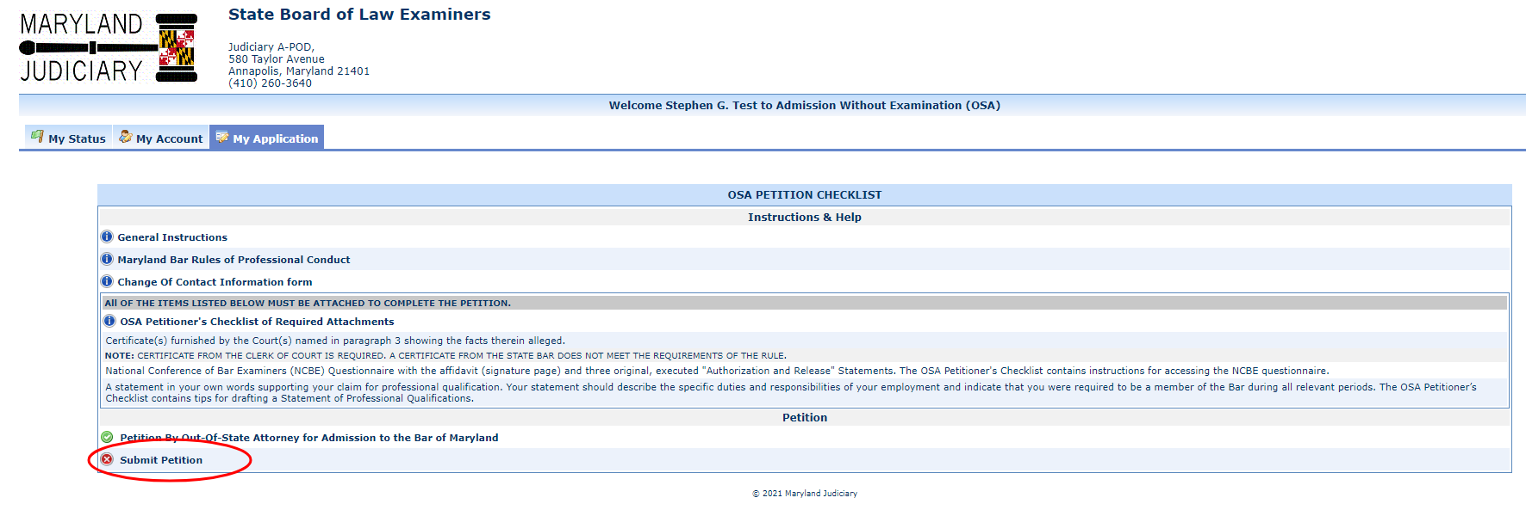
Figure 25 – Petition ready for submission.

Click “Submit Petition” to submit the Petition be shown a success message and a green “”

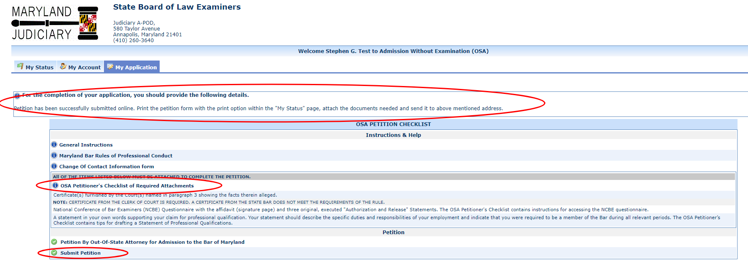
Figure 26 – Successfully submitted Petition

[Next page]

After submitting the Petition online, go to the My Status page and print the Petition using the printer icon.

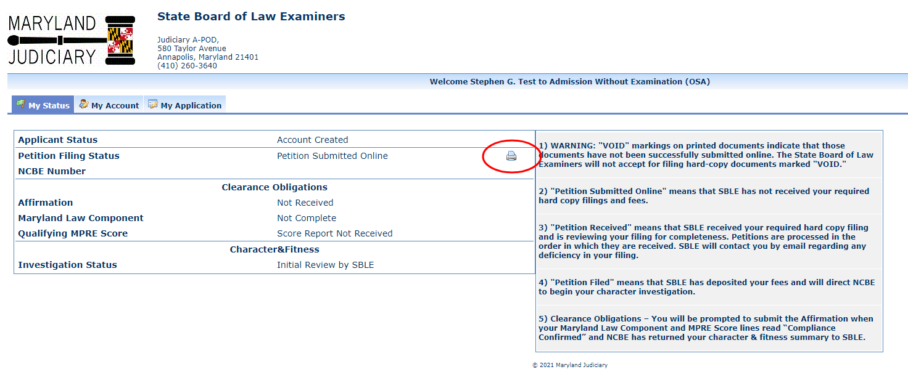
Figure 27 – My Status page showing Petition Submitted Online and printer icon.

CAUTION: If your printed document(s) contain(s) a “VOID” watermark, you did not electronically submit the documents. Go back to “My Application” and scroll down to the bottom of the page until you see “Submit Petition” Click on Submit and look for your confirmation message. Then return to My Status and re-print the document(s). You should now have no “Void” watermarks.

You must sign the printed Petition where indicated. You must also provide supplemental documentation as necessary in order for your bar application to be complete. Locate the Checklist of Petition Attachments (OSA) on the left-hand menu of SBLE’s website for details of the required attachments.

Only completed Petitions submitted online and in hard-copy with the required signatures and filing fee(s) will be treated as “filed” by SBLE. When SBLE processes your hard copy Petition along with original signatures and supplemental documents, your “My Status” page will display changes to your status. You may also receive e-mails from the eBar system when your status changes.

